**23CSE111**

**OBJECT ORIENTED PROGRAMMING**

**LAB REPORT**



**Department of Computer Science Engineering**   **Amrita School of Computing**

**Amrita Vishwa Vidyapeetham, Amaravati Campus**

**Name: K.R.N Bhanu Teja**

**Roll No: 24210**

**Verified By :**

**Index**

|  |  |  |
| --- | --- | --- |
| **S.No** | **Title** | **Pgno** |
| **1** | **Week-1** | **3-7** |
| **2** | **Week-2** | **8-21** |
| **3** | **Week-3** | **22-29** |
| **4** | **Week-4** | **30-37** |
| **5** | **Week-5** | **38-50** |

|  |  |  |
| --- | --- | --- |
| **S.NO** | **Experiment** | **Page No** |
| **1** | **Installation of jdk21** | **4-5** |
| **2** | **Write a simple java program for printing Name, Class, Roll No, of a Student** | **6-7** |

**INDEX**

Week 1

# WEEK-1

1. **Process of Installing JDK (Java Development Kit)**

**Installing JDK (Java Development Kit):**

* 1. **Download JDK:**
* Go to the Oracle JDK download page in google and click on JDK-21 version which is Long term support (LTS) version.
* Click the download link as your operating system (Windows, macOS, or Linux).
  1. **Install JDK:**
* Once downloaded, run the installer.
* Follow the given instructions and keep clicking "Next" until it is done.
  1. **Set Environment Variables (Windows):**
* Open file explorer, then right click on This PC next select on properties then it will take you to the settings app then click on advanced system settings and then click on **Environment Variables**.
* Click on path and new under **System Variables**:

**Variable value:** The folder address where JDK is installed (like

C:\Program Files\Java\jdk-21\bin)

* Find Path under **System Variables**, click **New**, and add the path of the jdk-21(C:\Program Files\Java\jdk-21\bin)

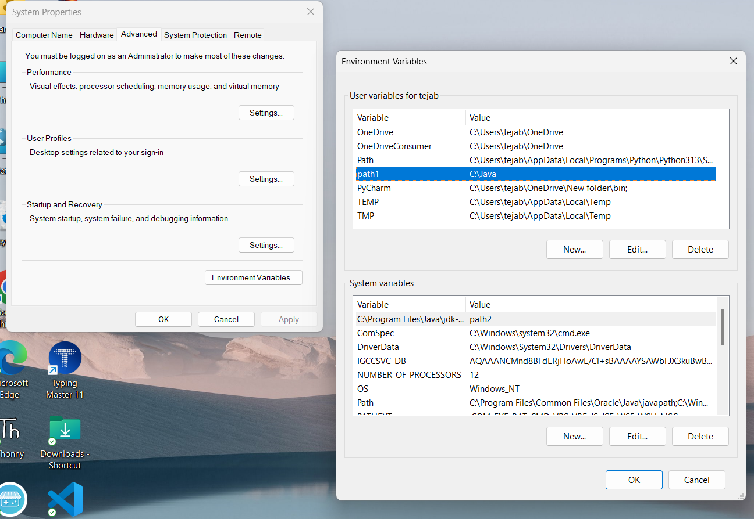

**Checking JDK Version: -**

* 1. **Open Command Prompt:**
* Presswin+R, typecmd, and press Enter.
  1. **Check Version:**
* Type java -version and press Enter.
* Type javac --version and press Enter.

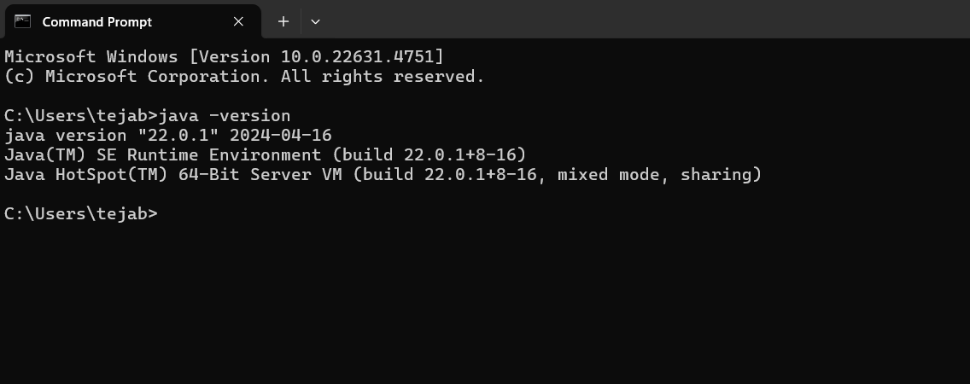

1. **Simple Java Program for printing Name, Class, Roll No, of a Student**

Aim:

Write your code in Notepad and execute it in cmd prompt

**CODE: -**

class Main

{

public static void main(String[] args)

{

System.out.println("Name: K.R.N Bhanu Teja");

System.out.println("Class :CSE-C");

System.out.println("Roll No:24210");

}

}

**Output: -**

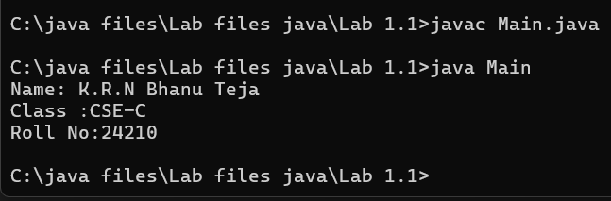

Errors

|  |  |  |
| --- | --- | --- |
| 1 | Syntax error | Semicolon added |
| 2 | Runtime error | Copied correct path |
| 3 | Name error | rectified |

Negative Case:

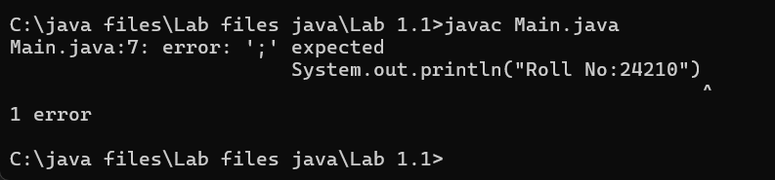

Week-2

|  |  |  |
| --- | --- | --- |
| S.No | Title | Pg no |
| 1 | Write a java program to find simple interest where all inputs are taken from user | 9-10 |
| 2 | Write a java program to calculate factorial of a number , read the input from user | 10-12 |
| 3 | Write a java program to calculate the Fibonacci  Sequence of a input taken from user | 12-14 |
| 4  A | Write a java program to convert temperature from Celsius to Fahrenheit | 14-15 |
| 4  B | Write a java program to convert temperature from Fahrenheit to Celsius | 16-17 |
| 5 | Write a java program to calculate the area of rectangle | 17-19 |
| 6 | Write a java program to calculate the area of triangle by using heron’s formula | 19-21 |

1. **Write a Simple Java Program for finding simple interest by taking input**

**from User**

**Code:**

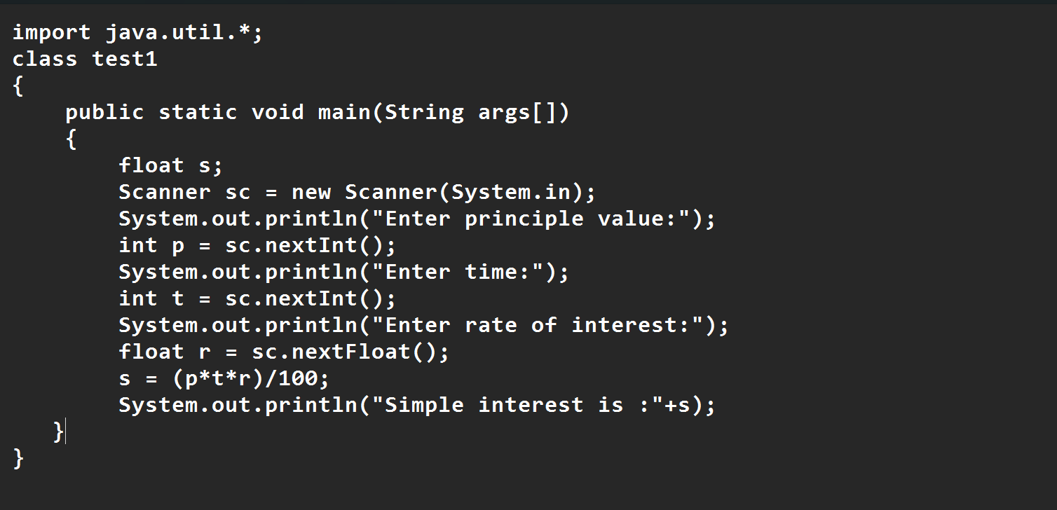

**Output:**

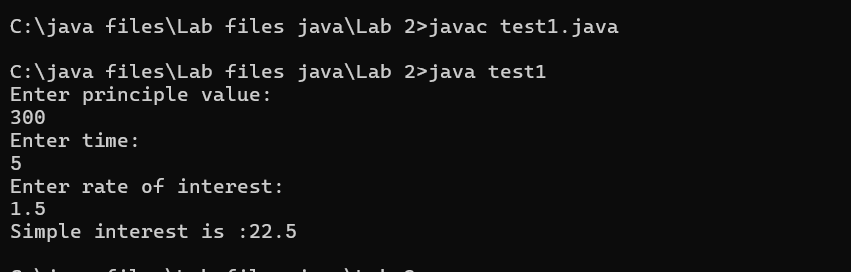

**Negative Case:**

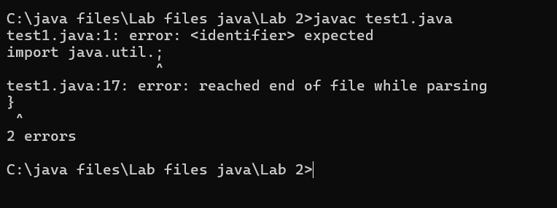

**Error Table:**

|  |  |  |  |
| --- | --- | --- | --- |
| **S.No** | **Error type** | **Reason for error** | **rectification** |
| **1** | **Runtime error** | **Incorrect path** | **Copied correct path** |
| **2** | **Syntax error** | **{ missing** | **{ added** |
| **3** | **Logical error** | **Wrong formula** | **Formula rectified** |

**2.Aim: Write a simple java program to calculate factorial of a number and read the**

**input from user**

**code:**

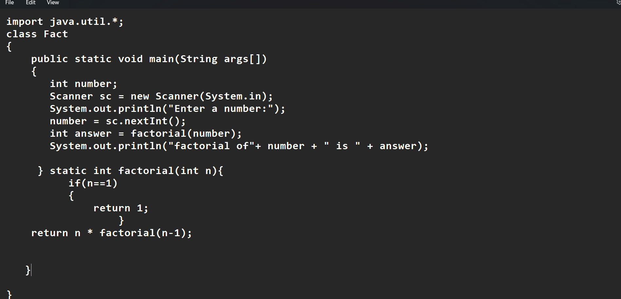

**Output:**

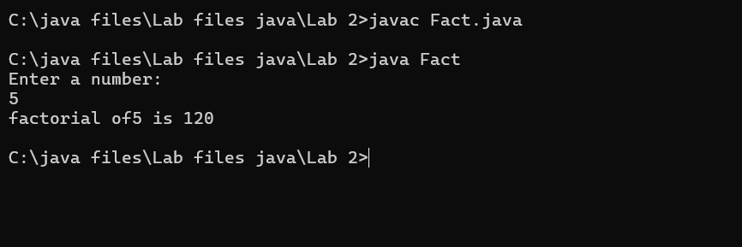

**Negative case:**

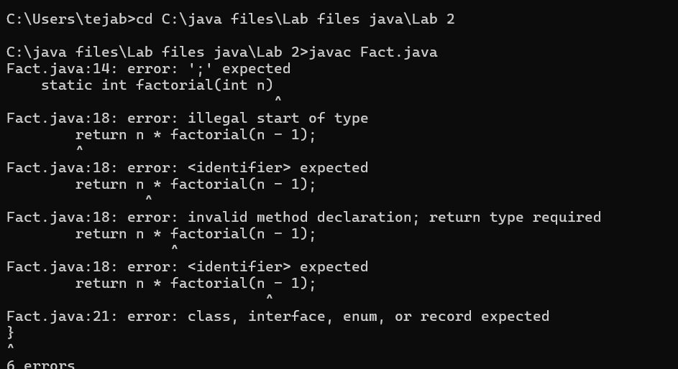

**Error table**

|  |  |  |  |
| --- | --- | --- | --- |
| **S.No** | **Error type** | **Reason for error** | **Rectification** |
| **1** | **Undeclared variable error** | **Missing variable** | **Variable declared** |
| **2** | **Missing import statement** | **Not importing packages** | **Packages imported** |
| **3** | **Logical error** | **Wrong formula** | **Formula rectified** |

**3.**

**Aim: Write a program to to calculate the fibonacii sequence and take the input**

**from user**

**Code:**

**import java.util.*;**

**class fibo**

**{**

**public static void main(String args[])**

**{**

**Scanner sc = new Scanner(System.in);**

**int num;**

**int f3;**

**int f1 = 0;**

**int f2 = 1;**

**int i = 2;**

**System.out.print("Enter a number:");**

**num = sc.nextInt();**

**System.out.println(f1);**

**System.out.println(f2);**

**while(i<num)**

**{**

**f3 = f1+f2;**

**f1 = f2;**

**f2 = f3;**

**System.out.println(f3);**

**i = i+1;**

**}**

**}**

**}**

**Output:**

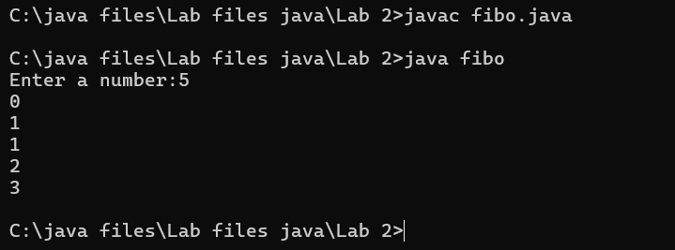

**Error Table:**

|  |  |  |  |
| --- | --- | --- | --- |
| **S.No** | **Error type** | **Reason for error** | **Rectification** |
| **1** | **Logical error** | **Incorrect formula** | **Formula rectified** |
| **2** | **Run-time error** | **Incorrect path** | **Added correct path** |
| **3** |  |  |  |

**Negative case:**

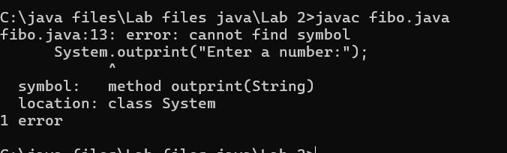

**Important points**

**Here the assignment operartion takes makes values are keep on updated for f1 and f2**

**4.A)**

**Aim: Write a java program to convert temperature from Fahrenheit to celsius**

**Code:**

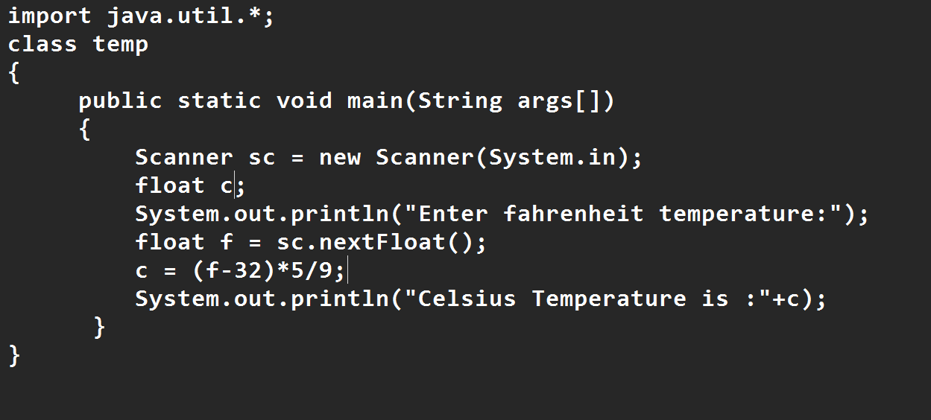

**Output:**

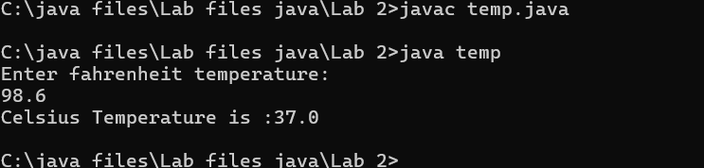

**Negative Case:**

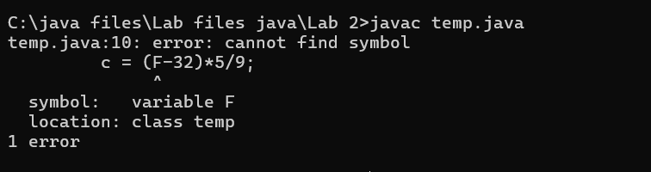

**Error Table:**

|  |  |  |  |
| --- | --- | --- | --- |
| **S.No** | **Error type** | **Reason for error** | **Rectification** |
| **1** | **Syntax error** | **Missing ”** | **“ is added** |
| **2** | **Missing import error** | **Util package missing** | **Util package added** |
| **3** | **Logical error** | **Incorrect formula** | **Formula rectified** |

**Important Points**

**Conversion of Fahrenheit to Celsius is c = (f-32)*5/9**

**4.b**

**Aim: Write a java program to convert temperature from Celsius to Fahrenheit**

**Code:**

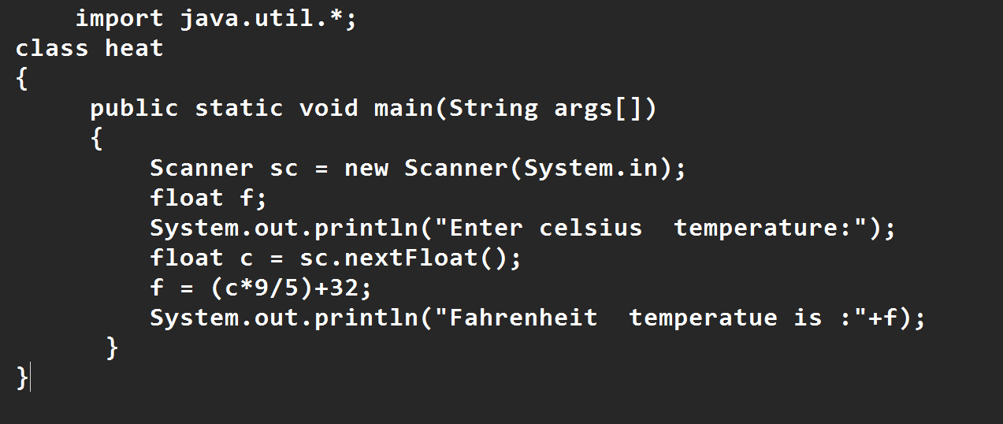

**Output:**

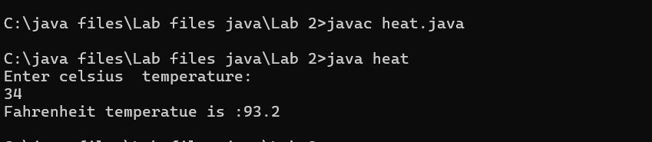

**Negative Case:**

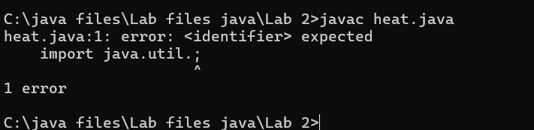

**Important points**

**Conversion of celsius to Fahrenheit is (c*9/5)+32**

**Error Table:**

|  |  |  |  |
| --- | --- | --- | --- |
| **S.No** | **Error type** | **Reason for error** | **Rectification** |
| **1** | **Runtime error** | **Incorrect path selection** | **Correct path added** |
| **2** | **Logical error** | **Incorrect formula** | **Correct formula**  **rectified** |
| **3** | **Import package error** | **Incorrect importing of**  **Packages** | **Imported util.*;**  **Package** |

**5.**

**Aim: Write a simple java program to find the area of rectangle:**

**Code:**

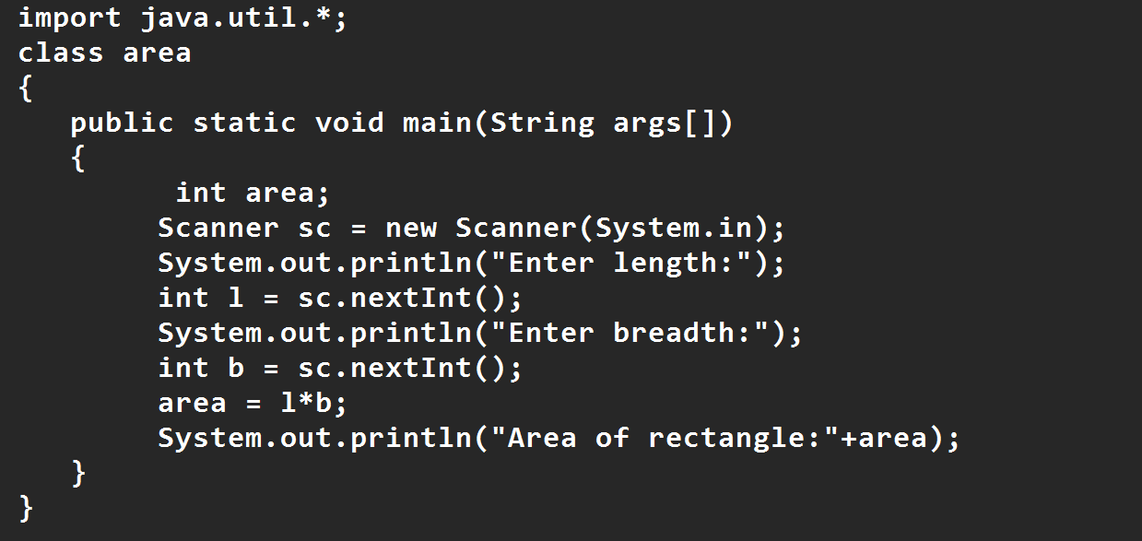

**Output:**

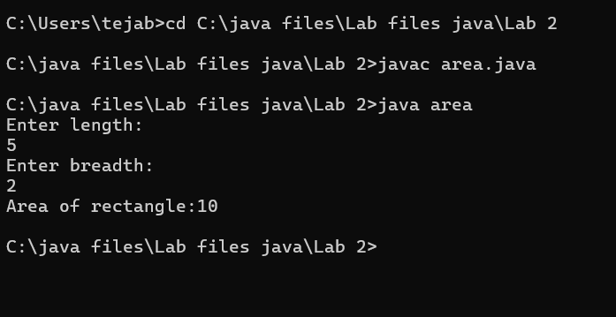

**Error Table:**

|  |  |  |  |
| --- | --- | --- | --- |
| **S.No** | **Error type** | **Reason for error** | **Rectification** |
| **1** | **Syntax error** | **Semi colon missing** | **Semi colon added** |
| **2** | **Missing import error** | **Import package missing** | **Import package added** |
| **3** | **Runtime error** | **Incorrect path selection** | **Rectified correct path** |

**Negative case:**

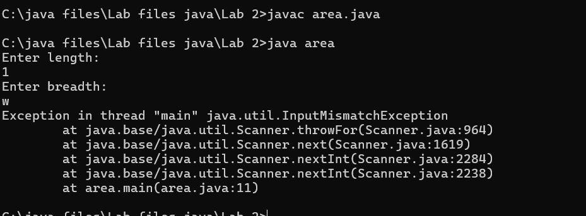

**6.Aim:**

**Write a program to find the area of triangle by using heron’s formula take the input from the user**

**Code:**

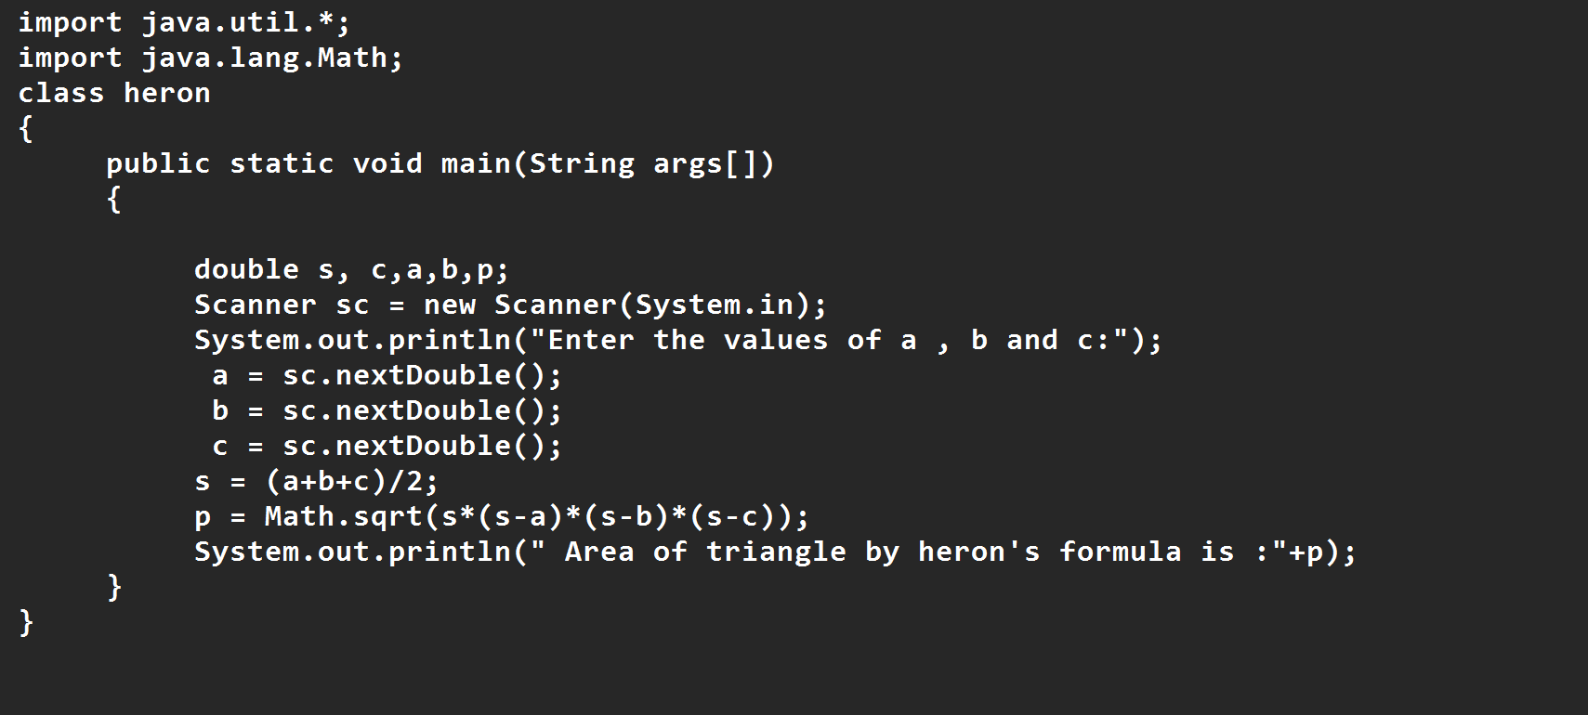

**OUTPUT:**

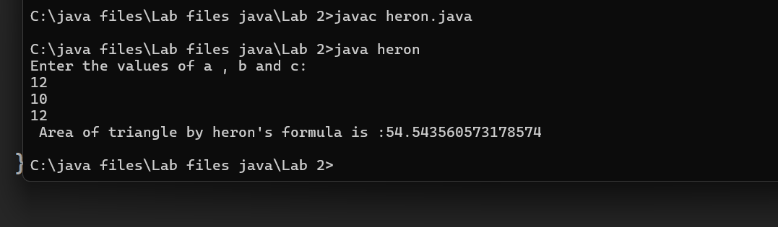

**Negative Case:**

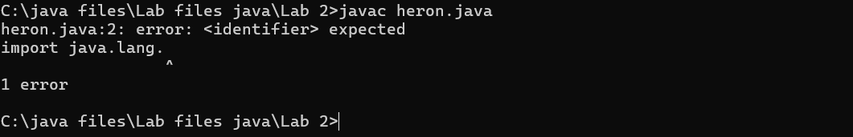

**Error Table**

|  |  |  |  |
| --- | --- | --- | --- |
| **S.No** | **Error type** | **Reason for error** | **Rectification** |
| **1** | **Logical error** | **Incorrect formula** | **Formula rectified** |
| **2** | **Name error** | **Undeclared variable** | **Variable declared** |
| **3** | **Import package error** | **Incorrect package** | **Package Recttified** |

**Important points**

**Import java.lang.Math is used to access the built in Math Class which provides a collection**

**of static methods**

**For performing various mathematical operations**

**Week-3**

|  |  |  |
| --- | --- | --- |
| S.No | Title | Pg no |
| 1 | Create a java program with following instructions   1. Create a class with name car 2. Create four attributes named Car_color , Car_brand, fuel_type,mileage 3. Create three methods named start(),stop(),service() 4. Create three objects named Car1, Car2 and Car3 | 23-26 |
| 2 | Create a class bankAccount with elements deposit() and Withdrawl | 26-29 |

**WEEK 3**

1. **Aim:**

**To create java program with following instructions**

**1.Create a class with name car**

**2. Create four attributes named car_color ,Car_brand,fuel_type,mileage**

**3. Create three methods named start(), stop(). Service()**

**4. Create three objects named car1,car2 and car3**

**Class Diagram:**

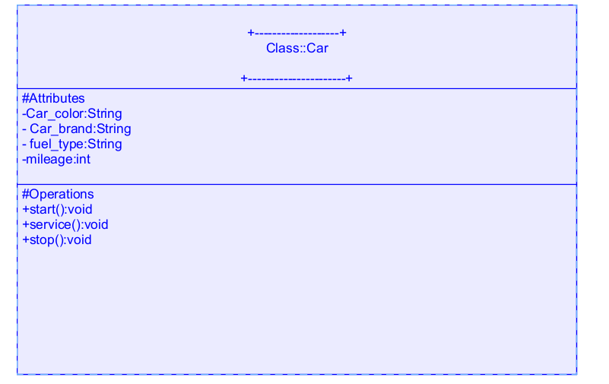

**Code:**

import java.util.*;

class car

{

public String Car_color;

public String Car_brand;

public String fuel_type;

public int mileage;

public void start()

{

System.out.println("Car Started:");

System.out.println("Car color is :"+Car_color);

System.out.println("Car Brand is:"+Car_brand);

System.out.println("Car fuel type is:"+fuel_type);

System.out.println("Car mileage is:"+mileage);

}

public void service()

{

System.out.println("Car Started:");

System.out.println("Car color is :"+Car_color);

System.out.println("Car Brand is:"+Car_brand);

System.out.println("Car fuel type is:"+fuel_type);

System.out.println("Car mileage is:"+mileage);

}

public void stop()

{

System.out.println("Car Started:");

System.out.println("Car color is :"+Car_color);

System.out.println("Car Brand is:"+Car_brand);

System.out.println("Car fuel type is:"+fuel_type);

System.out.println("Car mileage is:"+mileage);

}

public static void main(String args[])

{ System.out.println("\nBHANU TEJA\n\n");

car car1 = new car();

car1.Car_color = "Blue";

car1.Car_brand = "Audi";

car1.fuel_type = "Deisel";

car1.mileage = 100;

car1.start();

car car2 = new car();

car2.Car_color = "Red";

car2.Car_brand = "Tesla";

car2.fuel_type = "EV";

car2.mileage = 200;

car2.stop();

car car3 = new car();

car3.Car_color = "Yellow";

car3.Car_brand = "BMW";

car3.fuel_type = "Petrol";

car3.mileage = 300;

car3.service();

}

}

**Important points**

Methods: The set of instructions that can be called for execution using a method name.

**Output:**

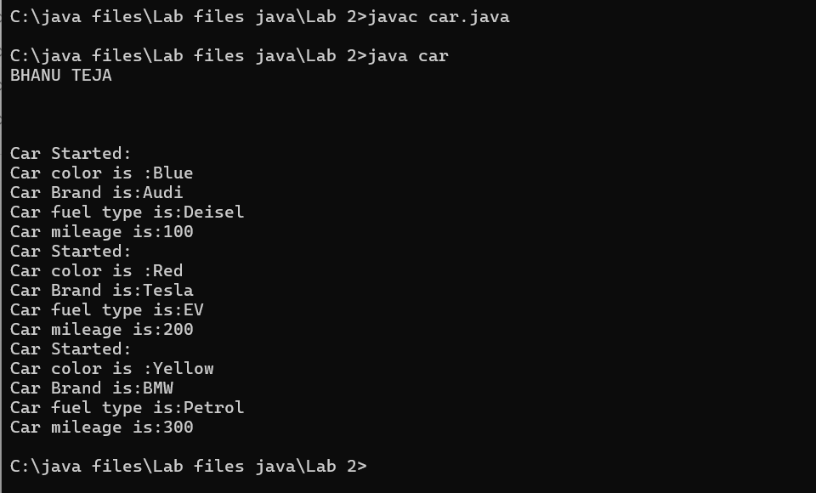

**Error Table**

|  |  |  |  |
| --- | --- | --- | --- |
| **S No** | **Error Type** | **Cause of error** | **Rectification** |
| **1** | **Syntax Error** | **Missing ‘{‘** | **‘{‘ added** |
| **2** | **Compile time Error** | **Mispelled Variable call** | **Rectified with**  **Correct variable name** |
| **3** |  |  |  |

**Negative Case**

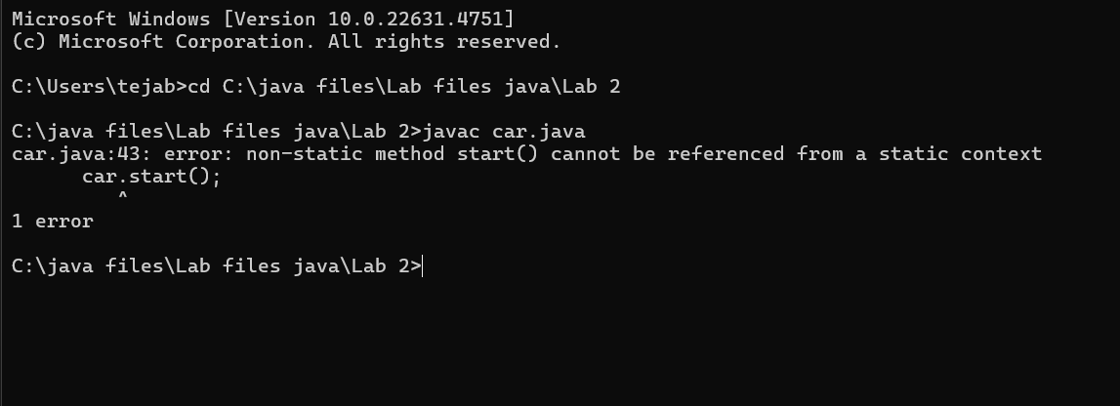

**2.**

**Aim: To create a class bankAccount with methods deposit() and withdrawl**

**Class Diagram**

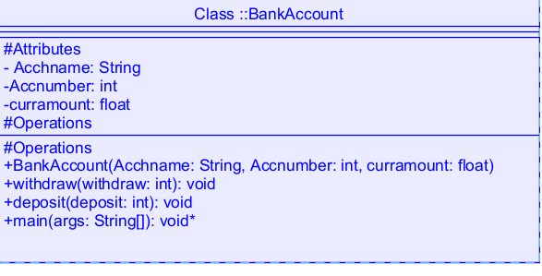

**Code:**

class BankAccount

{

public String Acchname;

public int Accnumber;

public float curramount;

BankAccount(String Acchname, int Accnum,float curramount)

{

this.Acchname = Acchname;

this.Accnumber = Accnumber;

this.curramount = curramount;

System.out.println("Enter Account holder name:"+Acchname);

System.out.println("Enter Account number:"+Accnum);

System.out.println("Enter current amount:"+curramount);

}

public void withdraw(int withdraw)

{

if(withdraw>curramount)

{

System.out.println("Insufficient Funds");

}

else

{

curramount = curramount-withdraw;

System.out.println("withdraw amount is:"+withdraw);

System.out.println("Current amount is:"+curramount);

}

}

public void deposit(int deposit)

{

System.out.println("Deposited amount is :");

curramount = curramount+deposit;

System.out.println("Deposited amount is:"+deposit);

System.out.println("Total current amount is:"+curramount);

}

public static void main(String args[])

{

BankAccount b = new BankAccount("Hari",24210,100000);

b.deposit(10000);

b.withdraw(500);

}}

**Output:**

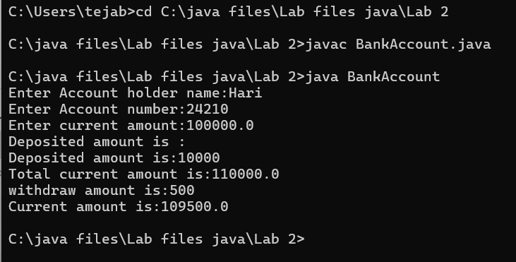

**Error Table:**

|  |  |  |  |
| --- | --- | --- | --- |
| **s.no** | **Error name** | **Cause of error** | **Rectification** |
| **1** | **Name Error** | **Undefined name** | **Correct variable**  **Name replaced** |
| **2** | **Syntax Error** | **Missing Parenthesis** | **Parenthesis Added** |
| **3** | **Logical Error** | **Incorrect Condition** | **Condition Rectified** |

**Negative Case**

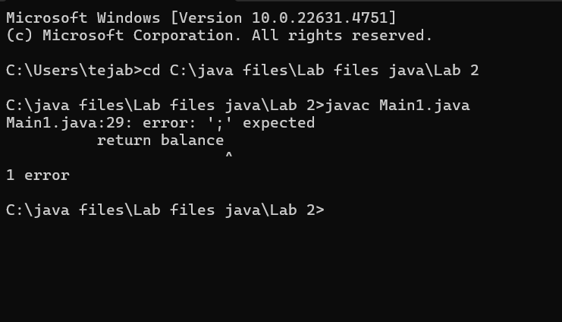

**Important points:**

**Constructor: The Constructor creates and initializes objects of a class. They are called**

**when an object is created to a class.**

**This Keyword: The This keyword refers to the current instance of a class.It is used to**

**Access class variables and methods.**

**Class Diagram**

**WEEK 4**

|  |  |  |
| --- | --- | --- |
| **S.No** | **Title** | **Pg no** |
| **1** | **Write a java program with class named book. The class The class should contain various**  **Attributes such as title, author, year of publication.**  **It should also contain a**  **Constructor with parameters which initializes title, author and year of**  **Publication.**  **Create a method which displays the details of the book .**  **Display**  **The details of two books** | **31-34** |
| **2** | **.Create a java program with class named “myclass” with a static variable**  **“count” of int type, initialized to zero and a constant variable “pi” of type**  **Double initialized to 3.14 as attributes of the class. Now define a constructor**  **For “myclass” that increments the count variable each time an object of**  **“myclass” is created**  **Finally Print the final values of count and pi variables. Create three objects** | **34-37** |

**Aim: Write a java program with class named book. The class should contain various**

**Attributes such as title, author, year of publication. It should also contain a**

**Constructor with parameters which initializes title, author and year of**

**Publication. Create a method which displays the details of the book .Display**

**The details of two books**

**Class Diagram**

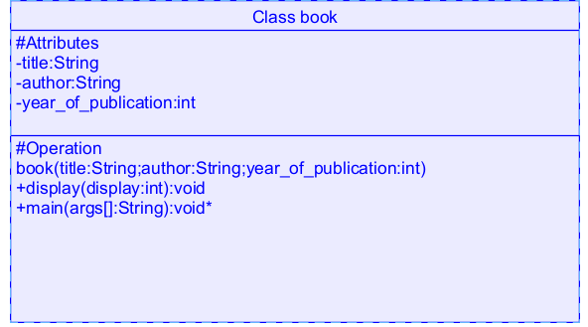

**Code**

**class book**

**{**

**public String title;**

**public String author;**

**public int year_of_publication;**

**book(String title, String author, int year_of_publication)**

**{**

**this.title = title;**

**this.author = author;**

**this.year_of_publication = year_of_publication;**

**}**

**public void display()**

**{**

**System.out.println("Title of book is:"+title);**

**System.out.println("Author of book is:"+author);**

**System.out.println("Year of publication is:"+year_of_publication);**

**}**

**public static void main(String args[])**

**{**

**book b1 = new book("Python","Bhanu",2023);**

**b1.display();**

**book b2 = new book("Java","Sushanth",2024);**

**b2.display();**

**}}**

**Important points:**

**Constructor:**

Constructor are special methods used to initialize objects when they are created

**Output:**

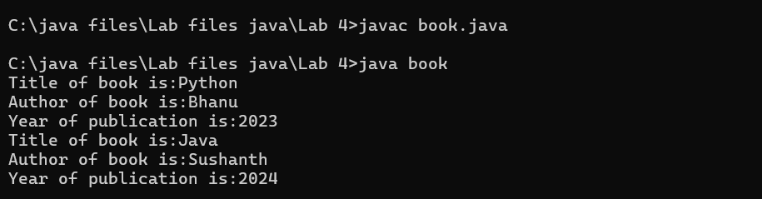

**Error Table:**

|  |  |  |  |
| --- | --- | --- | --- |
| **S.No** | **Error Type** | **Reason** | **Rectification** |
| **1** | **Syntax error** | **Missing {** | **Added {** |
| **2** | **Static method called non statically** | **Fault in calling the method** | **Rectified method**  **Calling** |
| **3** | **Run-time error** | **Incorrect Selection of**  **Path** | **Correct path**  **Selected** |

**Negative Case**

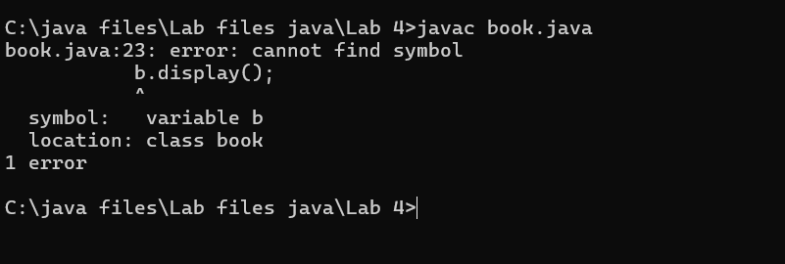

**2.Create a java program with class named “myclass” with a static variable**

**“count” of int type, initialized to zero and a constant variable “pi” of type**

**Double initialized to 3.14 as attributes of the class. Now define a constructor**

**For “myclass” that increments the count variable each time an object of**

**“myclass” is created**

**Finally Print the final values of count and pi variables. Create three objects**

**Class Diagram:**

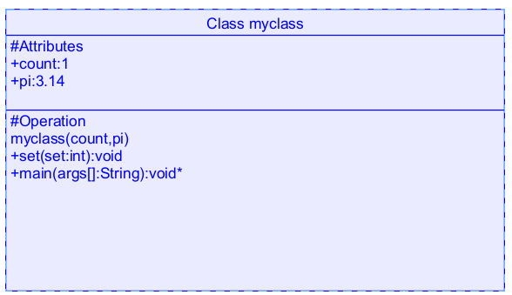

**Code:**

**class myclass**

**{**

**static int count=0;**

**static double pi=3.14;**

**myclass()**

**{**

**count = count+1;**

**}**

**public void set()**

**{**

**System.out.println("Count is:"+count);**

**System.out.println("Pi value is:"+pi);**

**}**

**public static void main(String args[])**

**{**

**myclass m = new myclass();**

**m.set();**

**myclass m1 = new myclass();**

**m1.set();**

**myclass m2 = new myclass();**

**m2.set();**

**System.out.println("Final count is:"+count);**

**System.out.println("Final value of pi is:"+pi);**

**}**

**}**

**Output:**

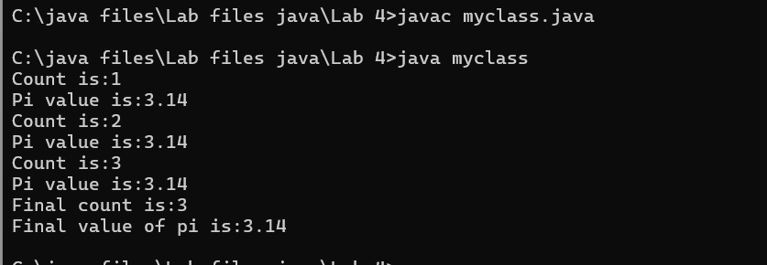

**Negative Case:**

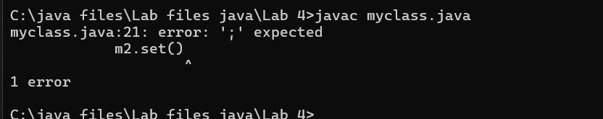

**Error Table:**

|  |  |  |  |
| --- | --- | --- | --- |
| S.No | Error Type | Cause | Rectification |
| 1 | Name error | Incorrect variable called | Rectified with correct variable |
| 2 | Syntax error | Missing semi-colon | Semi-colon added |
| 3 | Run time error | Incorrect path | Selected correct path |

Important Points

The count value increases and the loop repeats until the condition go wrong

WEEK-5

|  |  |  |
| --- | --- | --- |
| S.No | Title | Pgno |
| 1 | Create a calculator using the operations including addition, subtraction  Multiplication and division using multilevel inheritance and display the desired  Output | 40-45 |
| 2 | A vehicle rental company wants to develop a system that maintains  Information about different types of vehicles available for rent  The Company rents out cars, bikes and truck and they need a program to  Store details about each vehicle, such as brand and speed  Cars should have an additional property: number of doors  Bikes should have a property indicating whether they have gears or not  The system should also include a function to display details about each vehicle  And indicate when a vehicle is starting | 45-50 |

1.AIM: Create a calculator using the operations including addition, subtraction

Multiplication and division using multilevel inheritance and display the desired

Output

Class Diagram:

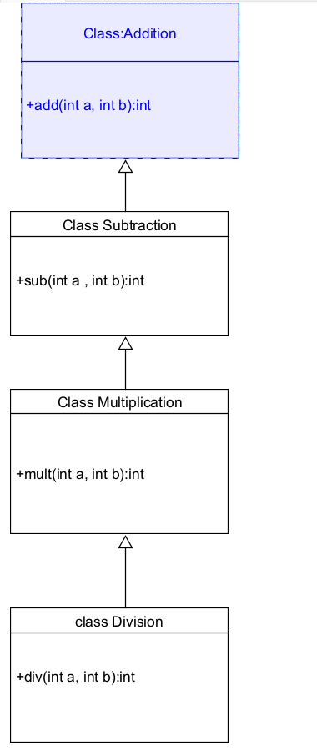

Code:

class addition

{

public int add(int a, int b)

{

int addition = a+b;

return addition;

}

}

class subtraction extends addition

{

public int sub(int a, int b)

{

int subtraction = a-b;

return subtraction;

}

}

class multiplication extends subtraction

{

public int mult(int a, int b)

{

int multiplication = a*b;

return multiplication;

}

}

class division extends multiplication

{

public int div(int a,int b)

{

int division = a/b;

return division;

}

}

class calculator

{

public static void main(String args[])

{

division obj = new division();

System.out.println("Addition is:"+ obj.add(10,2));

System.out.println ("Subtraction is:"+obj.sub(8,4));

System.out.println("Multiplication is:"+obj.mult(12,4));

System.out.println("Division is:"+obj.div(8,4));

  }

}

Output

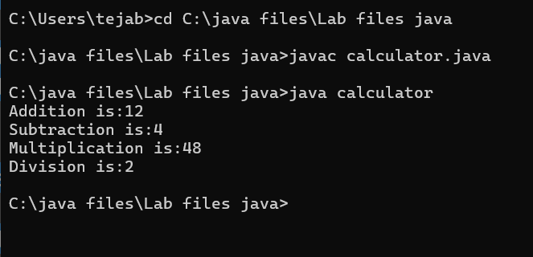

Error Table

|  |  |  |  |
| --- | --- | --- | --- |
| S.No | Error Type | Cause | Rectification |
| 1 | Constructor error | Invalid name to method | Defined class name |
| 2 | Syntax error | Expected ‘(‘ | Added parenthesis |
| 3 | Logical error | Incorrect arithmetic  operation | Correct operation  Rectified |

Negative Case:

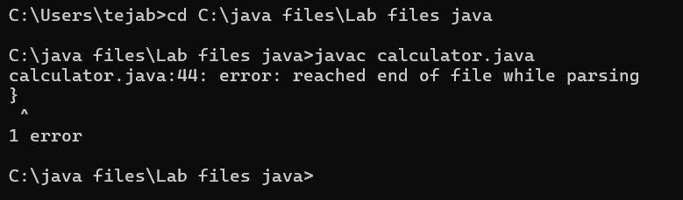

Important Points

Inheritence:

The concept of OOP where a class inherits the properties and behaviours from

Another class (parent class) which promotes code reusability and hieratchical relationships

Multilevel Inheritence:

This is a type of inheritance in which a class inherited from another class, and

That superclass, in turn, inherits from yet another class, creating a chain of

inheritence

extends:

The extends keyword defines the relation of child class with the parent class

2.

Aim: A vehicle rental company wants to develop a system that maintains

Information about different types of vehicles available for rent

The Company rents out cars, bikes and truck and they need a program to

Store details about each vehicle, such as brand and speed

Cars should have an additional property: number of doors

Bikes should have a property indicating whether they have gears or not

The system should also include a function to display details about each vehicle

And indicate when a vehicle is starting

Class diagram

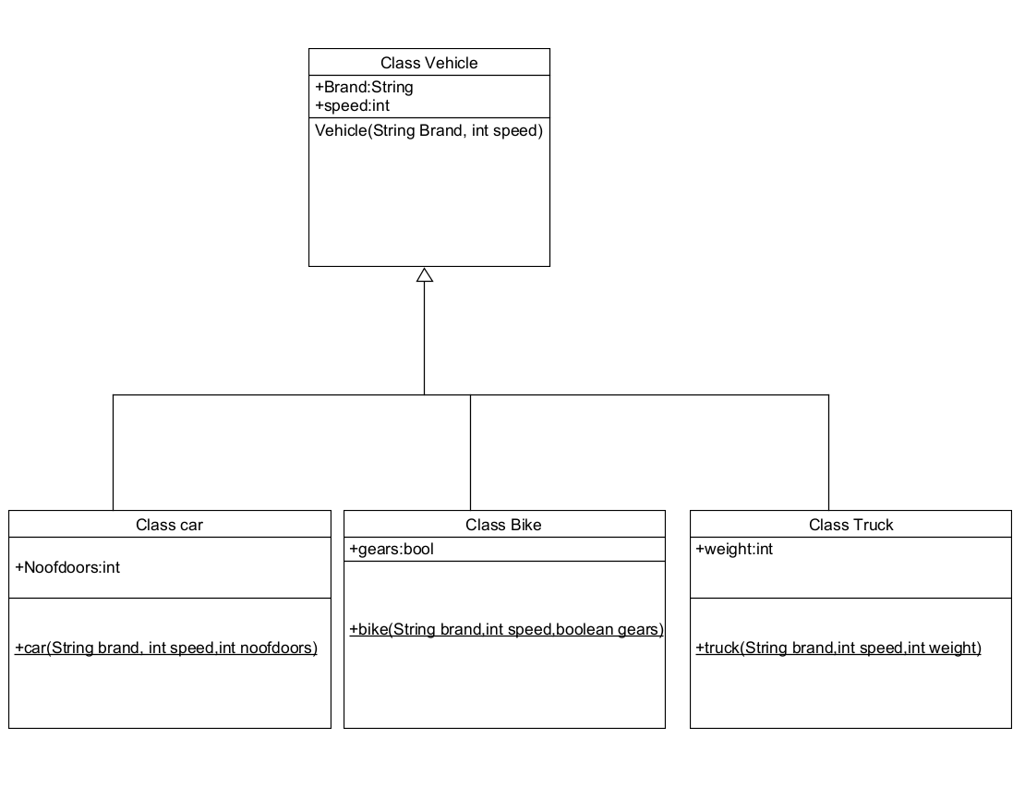

Code:

class vehicle{

String brand;

int speed;

public vehicle(String brand,int speed){

this.brand=brand;

this.speed=speed;

}

public static void main(String[] args) {

car obj1=new car("ford",34,4);

bike obj2=new bike("hero",100,true);

truck obj3=new truck("tata",60,40);

}

}

class car extends vehicle{

int noofdoors;

public car(String brand, int speed,int noofdoors) {

super(brand, speed);

this.noofdoors=noofdoors;

System.out.println("Brand of car is:"+brand);

System.out.println("Speed of car is:"+speed);

System.out.println("no of doors of car:"+noofdoors);

}

}

class bike extends vehicle{

boolean gears;

public bike(String brand,int speed,boolean gears){

super(brand, speed);

this.gears=gears;

System.out.println("Brand of bike is:"+brand);

System.out.println("Speed of bike is:"+speed);

System.out.println("Gears of bike:"+gears);

}

}

class truck extends vehicle{

int weight;

public truck(String brand,int speed,int weight){

super(brand,speed);

this.weight=weight;

System.out.println("Brand name is:"+brand);

System.out.println("Speed of Truck is:"+speed);

System.out.println("Weight of load is"+weight);

}

}

Output:

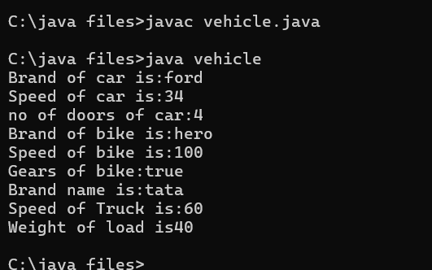

Error Table:

|  |  |  |  |
| --- | --- | --- | --- |
| S No | Error Type | Cause | Rectification |
| 1 | Syntax Error | Semicolon missing | Added ; |
| 2 | Class format error | Incorrect format of classes | Correct format rectified |
| 3 | Run time error | Exception at runtime | Exception rectified |

Negative Case:

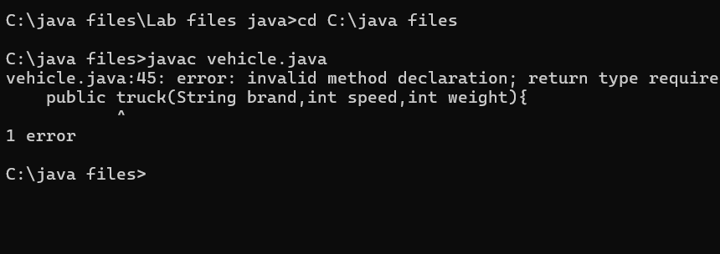

Important Points

Hierarchical Inheritence:

This is a type of inheritance occurs when multiple subclasses inherit from a

Single parent class

1. Aim:

Write a java program to create a vehicle class with a method displayInfo().

Override this method in the car subclass to provide specific information a

About car

Code:

class vehicle

{

public String car_model;

public String car_company;

public int car_price;

void displayinfo()

{

System.out.println("Bhanu Teja Car Agency");

}

}

class car extends vehicle

{

void displayinfo()

{

System.out.println("Car Model is:"+car_model);

System.out.println("Car Company is:"+car_company);

System.out.println("Car price is:"+car_price);

}

}

class Overriding

{

public static void main(String args[])

{

car obj1 = new car();

obj1.car_model="Swift";

obj1.car_company="Suzuki";

obj1.car_price=1000000;

obj1.displayinfo();

}

}

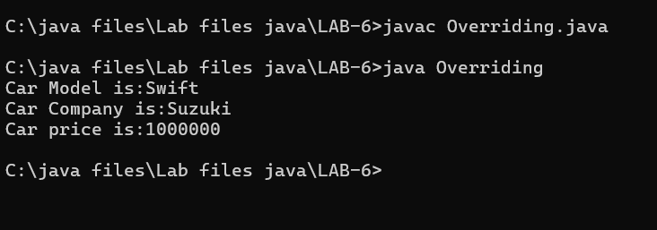

Error Table

Important Points

1. A college is developing an automated admission system that verifies

Student eligibility for UG and PG programs. Each program has different

Eligibility criteria based on the student’s percentage in their previous

Qualification

UG admissions require a minimum of 60%

PG admissions require a minimum of 70%

Code:

class Student

{

public String name;

public double percentage;

Student(String name, double percentage)

{

this.name = name;

this.percentage = percentage;

}

void eligibility()

{

System.out.println("Amrita Vishwa Vidyapeetham");

}

}

class UGStudent extends Student

{

UGStudent(String name, double percentage)

{

super(name,percentage);

}

void eligibility()

{

if (percentage>60)

{

System.out.println(name+" is selected to the college");

}

else

{

System.out.println(name+" is not matching the required criteria");

}

}

}

class PGStudent extends Student

{

PGStudent(String name, double percentage)

{

super(name,percentage);

}

void eligibility()

{

if(percentage>70)

{

System.out.println(name+" is selected to college");

}

else

{

System.out.println(name+"is not matching the required criteria");

}

}

}

class School

{

public static void main(String args[])

{

PGStudent obj1 = new PGStudent("Bhanu",90.0);

UGStudent obj2 = new UGStudent("Teja",80.0);

obj1.eligibility();

obj2.eligibility();

}

}

Output:

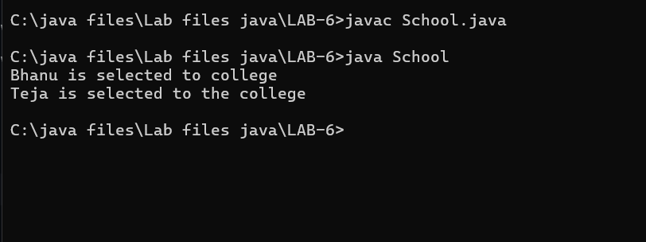

Create a calculator class with overloaded methods to perform addition

1. Add two integers 2. Add two doubles 3. Add three integers

Code:

class calculator

{

public int add(int a, int b)

{

return a+b;

}

public double add(double a, double b)

{

return a+b;

}

public int add(int a, int b, int c)

{

return a+b+c;

}

}

class Overloading

{

public static void main(String args[]){

calculator c = new calculator();

System.out.println("Addition of 3 and 4 is:"+c.add(3,4));

System.out.println("Addition of 2.2 and 4.4 is:"+c.add(2.2,4.4));

System.out.println("Addition of 2 4 6 is:"+c.add(2,4,6));

}}

Output:

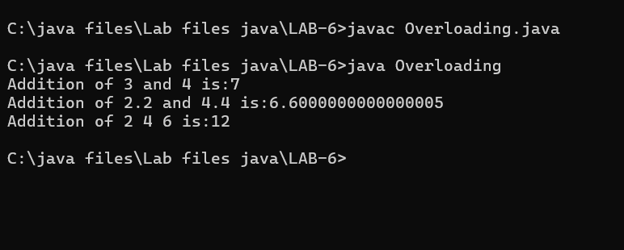

4 Create a Shape class with a method calculateArea() that is overloaded for

Different shapes. Then, create a subclass circle that overrides the

calculateArea() method for a circle

Code:

class shape

{

public double calculateArea(double side)

{

return side*side;

}

public int calculateArea(int length, int width)

{

return length*width;

}

}

class circle extends shape

{

public double calculateArea(double radius)

{

return 3.14*radius*radius;

}

}

class Example

{

public static void main(String args[])

{

circle obj1 = new circle();

shape obj2 = new shape();

System.out.println("The area of side 6 is:"+obj2.calculateArea(2.0));

System.out.println("The area of circle with radius 3 :"+obj1.calculateArea(3.0));

System.out.println("The area of length 3 and width 4 is:"+obj2.calculateArea(3,4));

}

}

Output:

